- Account and User Management

UC1. Create a Personal Checking Account
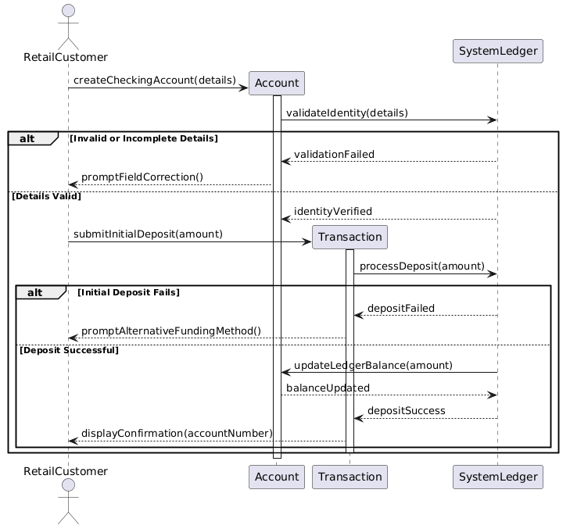
Made by: Orest Zeqollari

UC 02: Initiate Bulk Payroll Processing
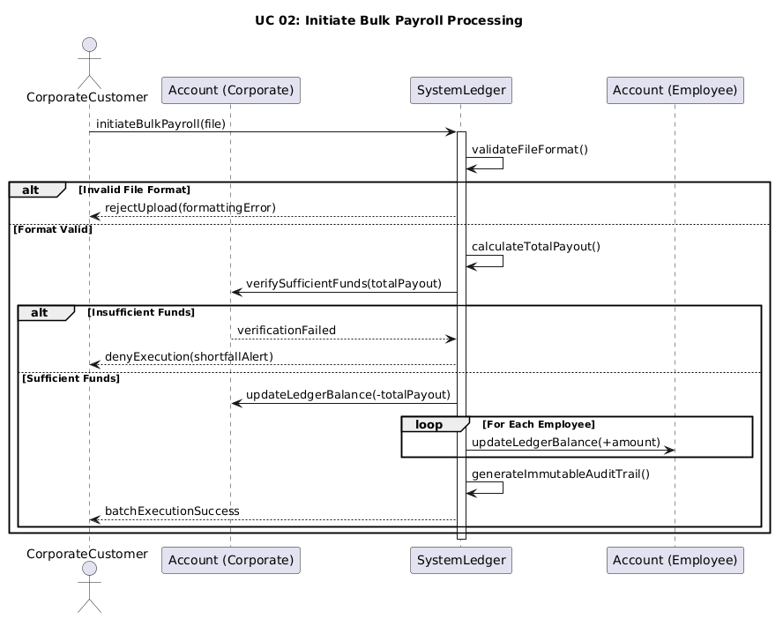
Made by: Orest Zeqollari

UC 03: Manage Multiple Authorized Signers
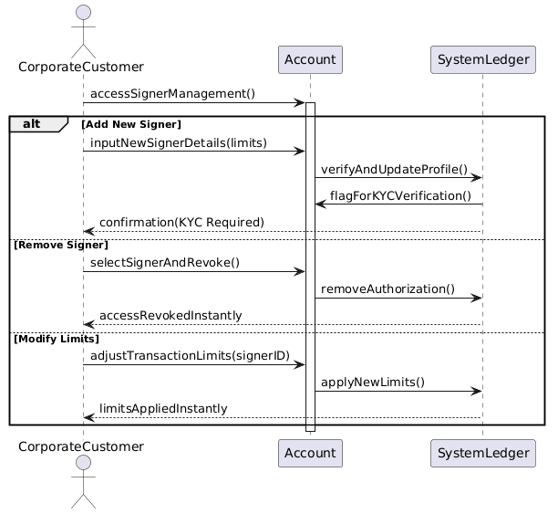
Made by: Orest Zeqollari

UC 04: Update KYC Documents
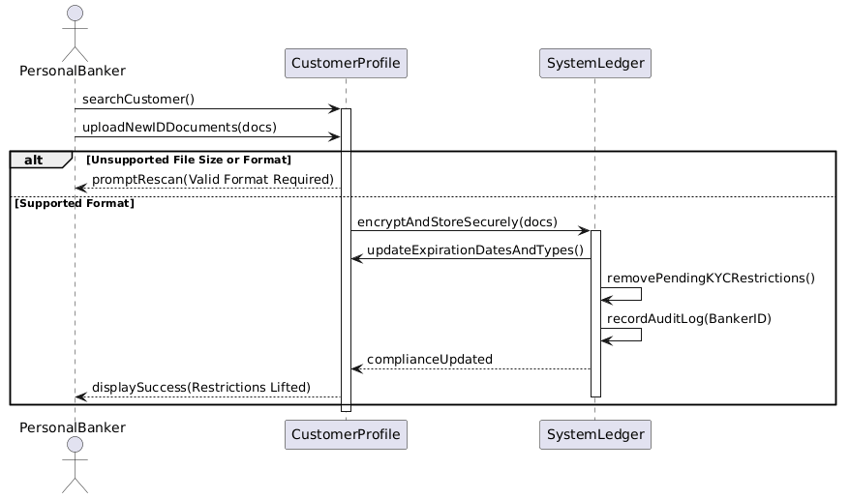
Made by: Aksel Luarasi

UC 05: Manage User Accounts (HR)
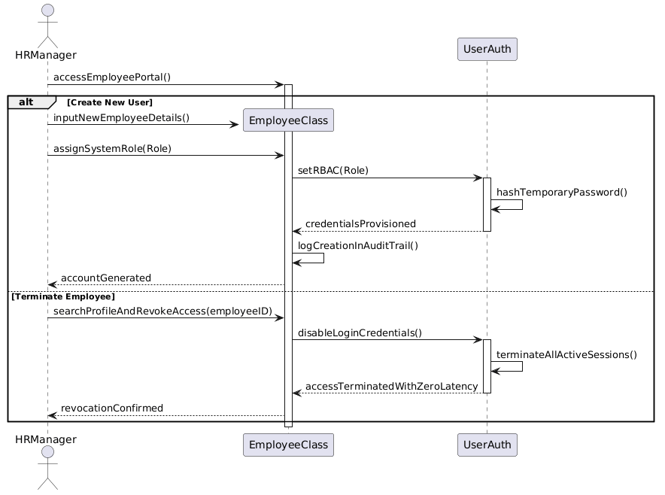
Made by: Aksel Luarasi

- Transactions and Cash Operations

UC 06: Process Cash Transactions
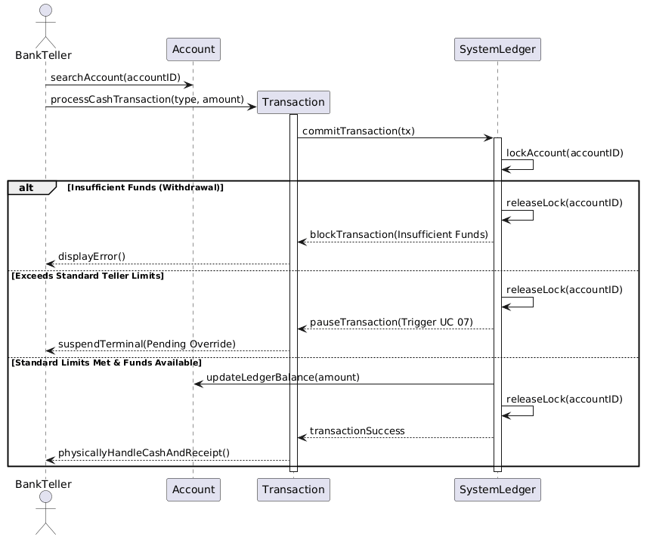
Made by: Aksel Luarasi

UC 07: Authorize Transaction Overrides
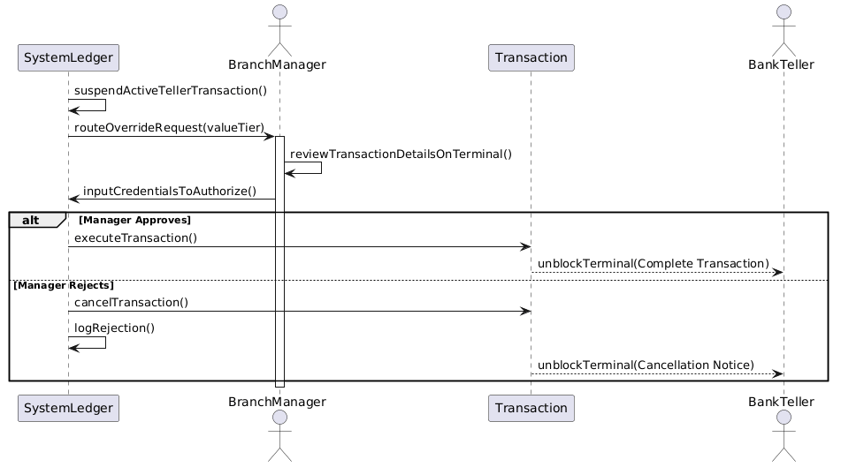
Made by: Kristian Avrami

UC 08: Manage Branch Cash and Vault Operations
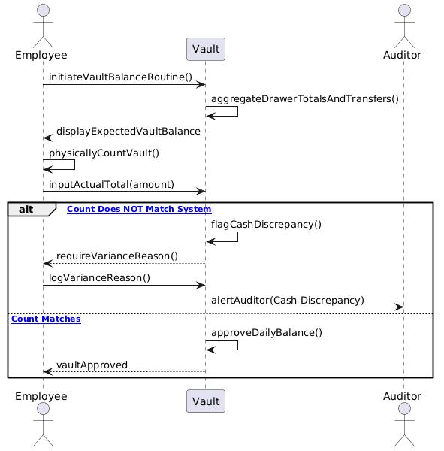
Made by: Kristian Avrami

UC 09: Settle External Transfers
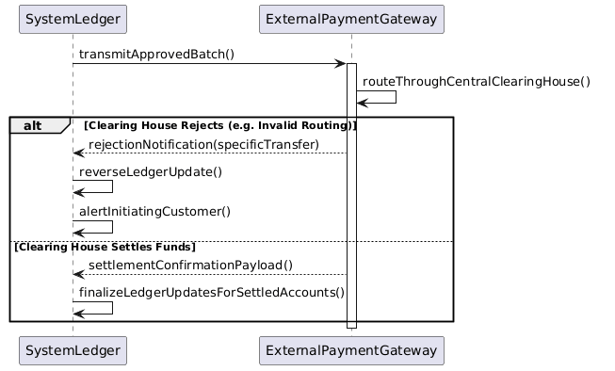
Made by: Kristian Avrami

3. Credit & Loan Processing

UC 10: Evaluate Loan Applications
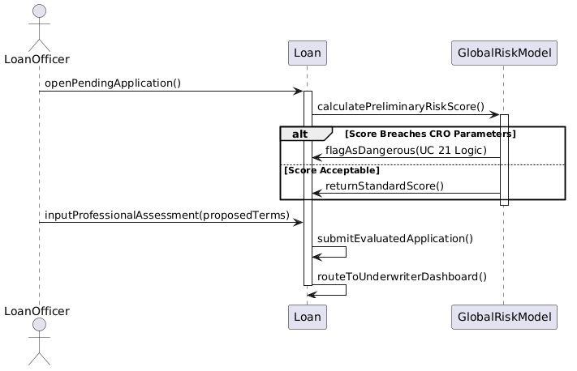
Made by: Erald Saraci

UC 11: Underwrite and Bind Loan Agreement
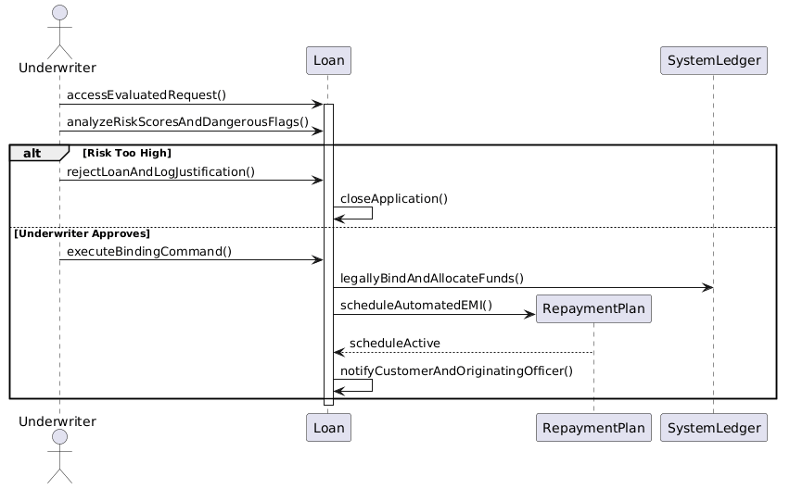
Made by: Erald Saraci

UC 12: Manage Defaulted Accounts and Asset Recovery
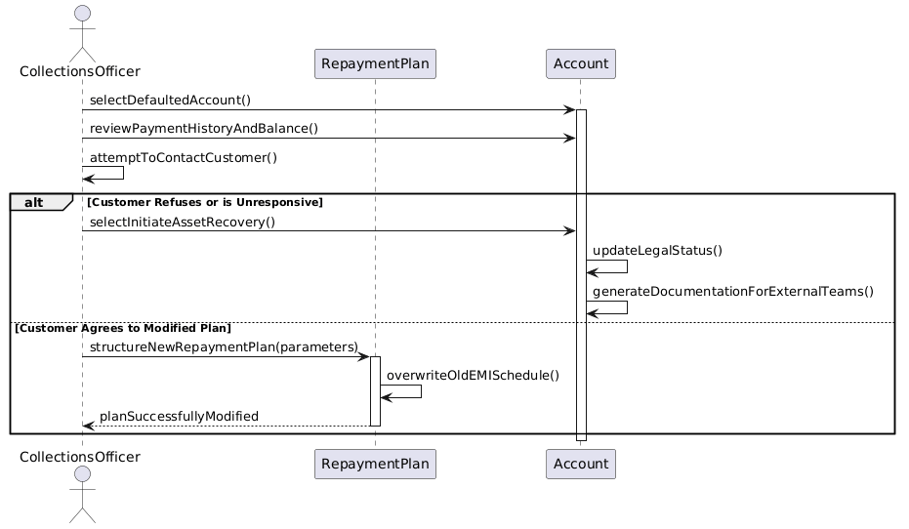
Made by: Denis Robi

4. Monitoring, Security and Admin

UC 13: Monitor Transactions and Generate AML Reports
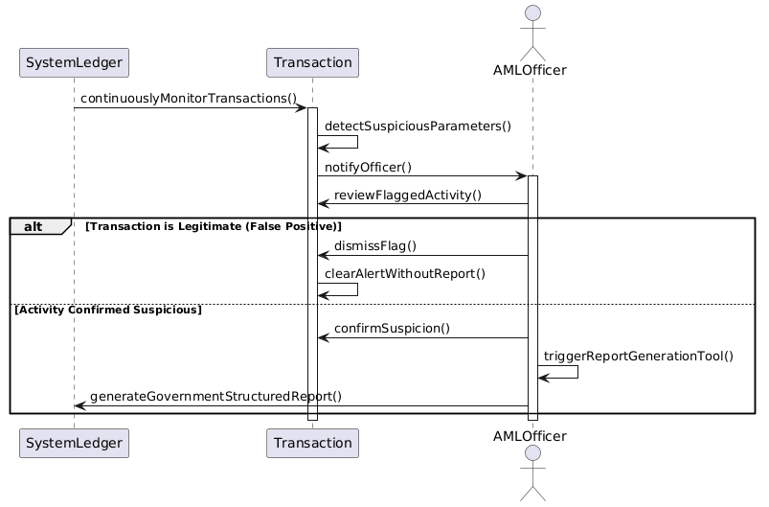
Made by: Denis Robi

UC 14: View Action History and Audit Logs
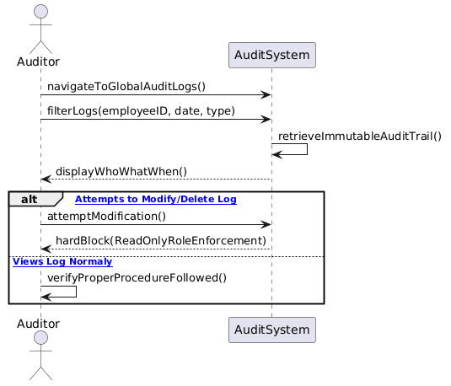
Made by: Denis Robi

UC 15: View Profitability and Transaction Summaries
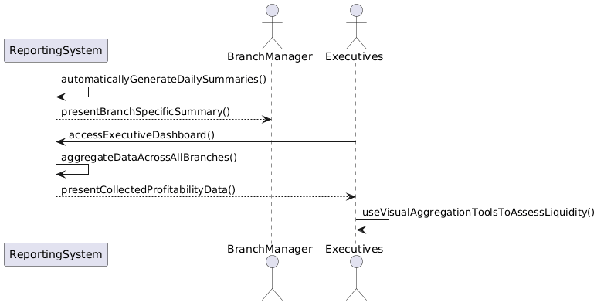
Made by: Denis Robi

UC 16: Manage Core System Configurations and Backups
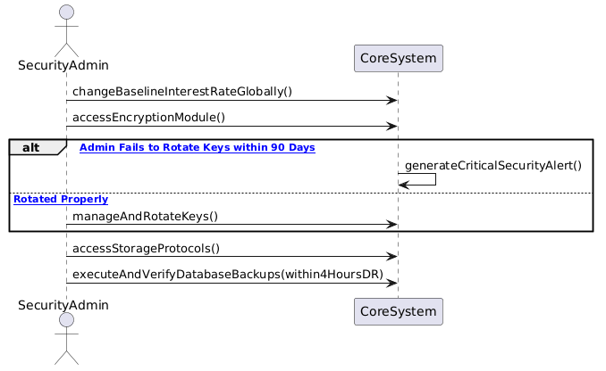
Made by: Daniel Salianji

5. Remaining Core Operations & System Actors

UC 17: Generate Account Statements
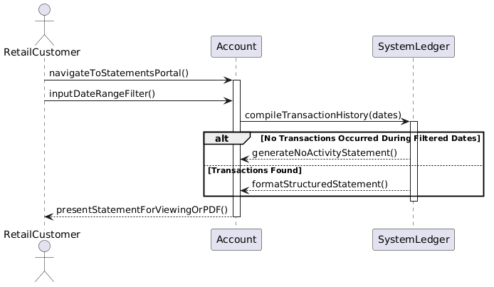
Made by: Daniel Salianji

UC 18: Issue New Debit Card
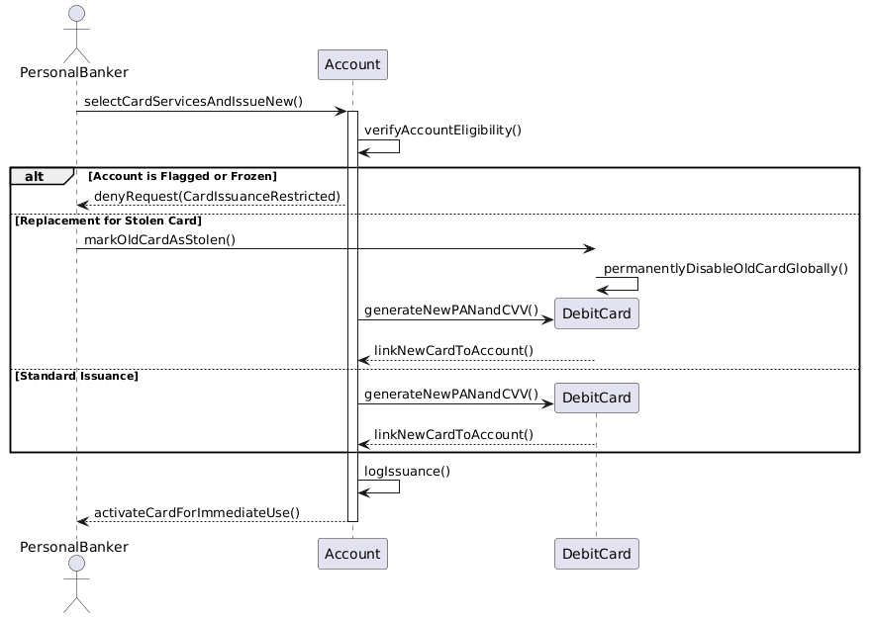
Made by: Daniel Salianji

UC 19: Authenticate User

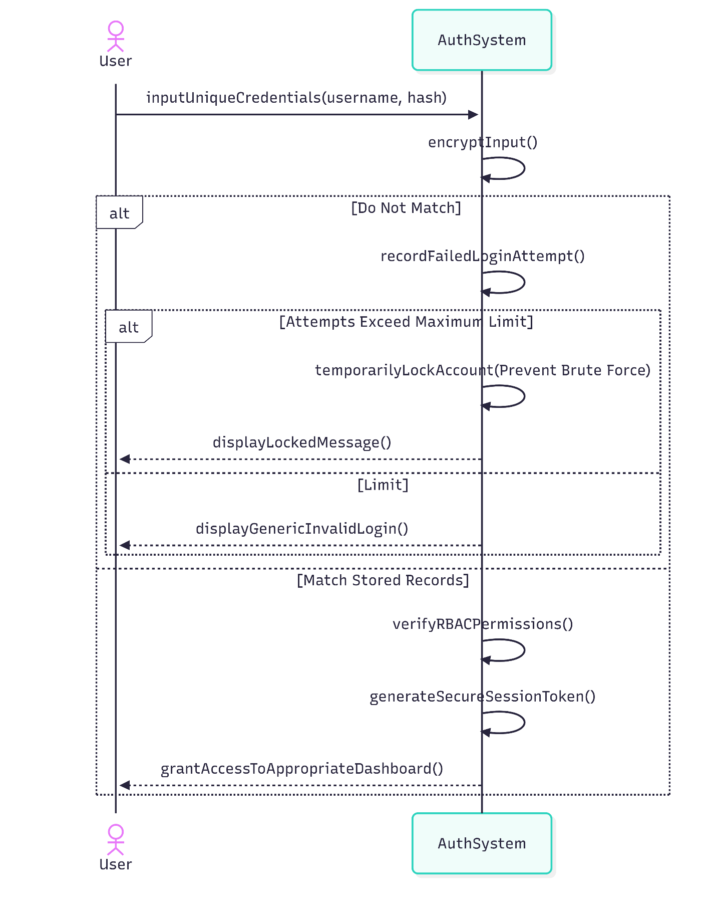
Made by: Denis Musaraj

UC 20: Set Global Risk Parameters
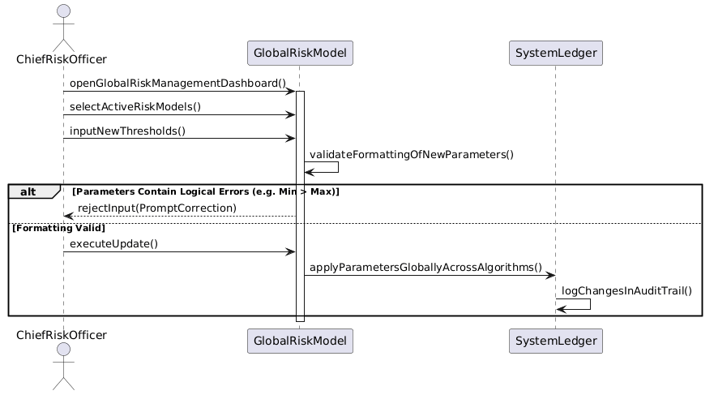
Made by: Denis Musaraj

UC 21: Flag Dangerous Loans (System Actor)
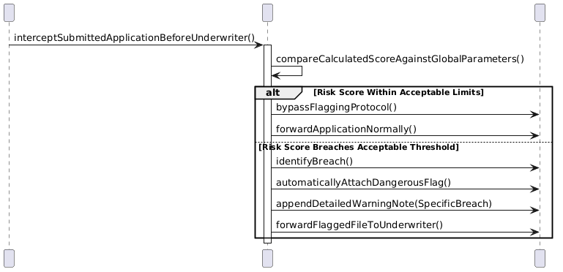
Made by: Denis Musaraj

UC 22: Route Loan Requests (System Actor)
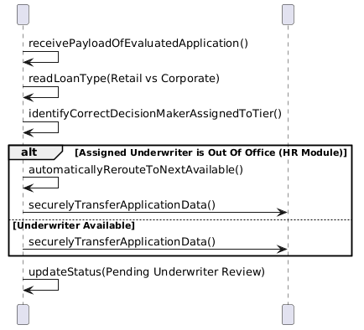
Made by: Dariel Hamzallari

UC 23: Update Ledger Balances in Real-Time (System Actor)
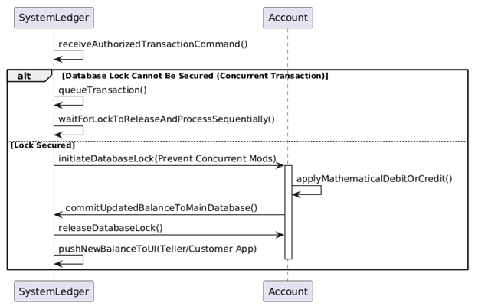
Made by: Dariel Hamzallari

UC 24: Generate Daily Transaction Summaries (System Actor)
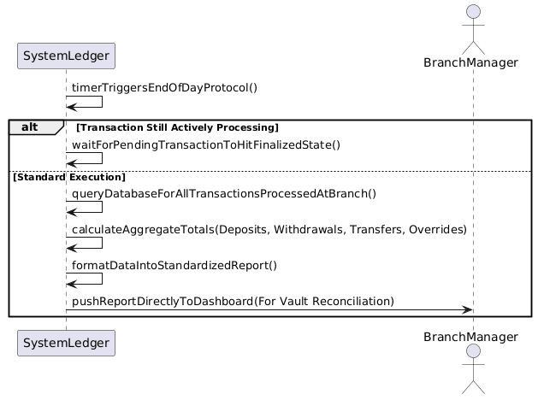
Made by: Dariel Hamzallari

